- Hero section:
Top badge:
Built for Façade & Construction Teams
Hero section heading:
Intelligent Systems for the Façade & Construction Industry
Paragraph:
We design AI-powered platforms, automation, and custom software that streamline construction workflows—from drawings and estimation to site operations and project delivery.
CTA
Book a Discovery Call
Explore Solutions
Hero section small stats cards:
-Workflow-First Approach
-Custom-Built Systems
-Built for Façade Teams
2- Who We help (Already done where you have shown trade cards).
Top badge:
Instead of “Across the envelope”
Use “Who We Build For”
Heading: “Built for the Specialists Behind Modern Buildings.”
Paragraph: From façade engineering to wider construction operations, we build intelligent systems around the way these teams work.

3- The problems We Solve (Design would be same as Why companies choose AI)
Top Badge:
“Where We Create Impact”
Heading: Construction moves fast (dark green colour). Your workflows should too (Olive color).
Paragraph:
Every project depends on hundreds of repetitive decisions—from reviewing drawings and preparing quotations to tracking fabrication and documenting site progress. We build intelligent systems that remove friction from these everyday workflows.
Right side cards:
- Manual Estimation
Still reviewing drawings manually and building quotations in spreadsheets?
- Drawing Revisions
Tracking revisions across multiple drawing versions wastes engineering hours.
- Site Reporting
Disconnected inspections slow communication between site and office.
- Fabrication Tracking
Production, installation and documentation often live in separate systems.
Use Respective icons on Cards.
After last card. One sentence fades in.
“Every workflow is different. That's why every solution we build starts with understanding how your team works.” Then next section (Service section) is shown.
4-Our Services
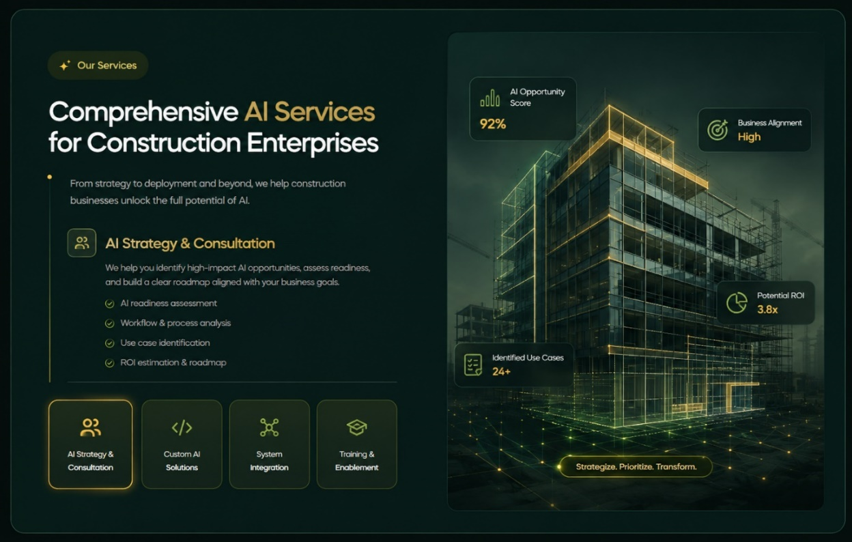
Badge:
HOW WE HELP
Heading:
From Workflow Challenges to Working Solutions.
Paragraph:
Every construction business operates differently. We combine software engineering, AI, and deep workflow understanding to build systems.
Services:
1- Workflow Analysis & Consulting
Description:
We study how your teams work today, identify where time and accuracy are being lost, and define the opportunities where custom software or AI can create real.
Points:
- Workflow & process assessment
- Operational bottleneck analysis
- Automation opportunity mapping
- Solution roadmap & recommendations
2-Custom AI Development
Description:
Every solution is built specifically for your business, not adapted from a generic product.
Points:
- Drawing & document intelligence
- Workflow automation
- AI assistants & copilots
- Computer vision & data extraction
3-Integration Services
New systems should work with the tools you already rely on. We integrate systems with your existing systems to make a digital environment.
Points:
- API integrations
- BIM & drawing workflows
- ERP / CRM connectivity
- Data synchronization
4-Training & Implementation
Heading:
Training & Implementation
Description
We support your team through onboarding, training, rollout, and continuous improvements to ensure every solution becomes part of your daily operations.
Points:
- Team onboarding
- Implementation planning
- User training
- Ongoing support

- Our featured Solutions Section
Section badge:
“FEATURED SOLUTIONS”
Heading:
Systems Built for Real Construction Workflows.
Paragraph:
Explore a selection of client systems, internal products, and innovation projects designed to streamline operations, reduce manual work, and improve the way construction teams deliver projects.
Each Product card should have:
- [ Category Badge]
- Solution Mockup
- Solution name
- One line description
- Button (shows only on hover)
Note:
For this change you must increase card height and increase card width as well and show only 2 solutions in a row. Total show 4 solutions in featured section.
Follow this structure for card: but keep design, colors same as you made previously.
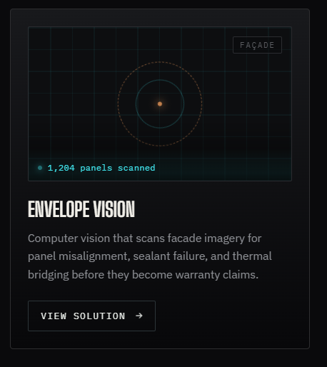

For now Do till this:
--------------------------------------------------------------------------------------------------------------

6- Our AI Transformation Framework
Make this section looks like Storyline
Discover -> Consult ->Design ->Develop -> Integrate -> Train -> Optimize
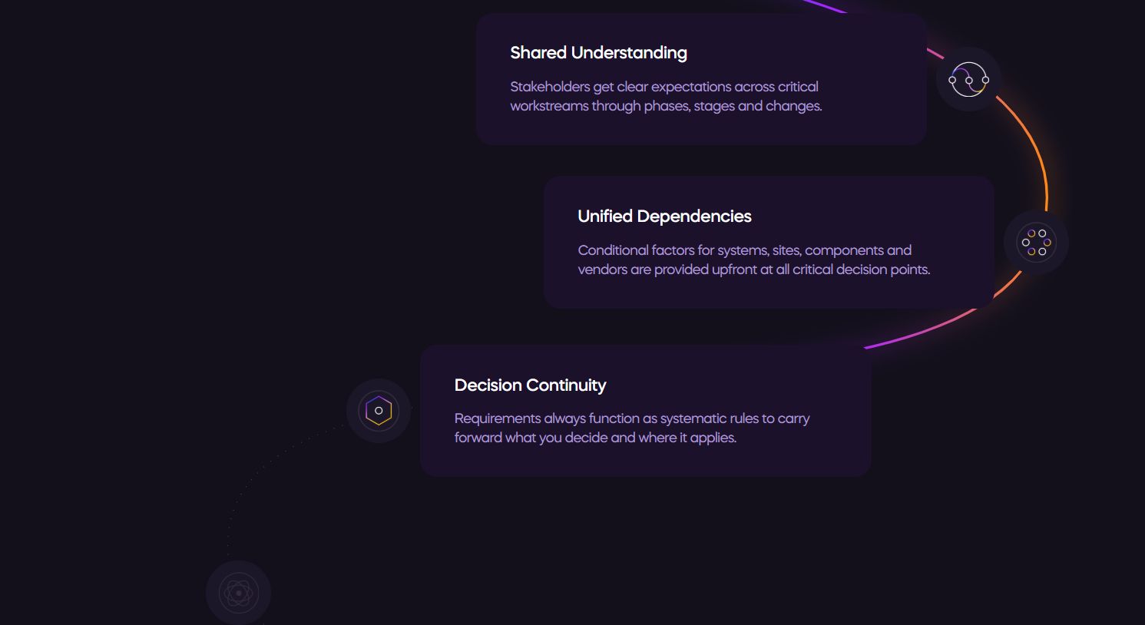
Use this content: (Don’t use the structure and style of the image below, just use its Text), but make the story line as given in the reference website (above image).
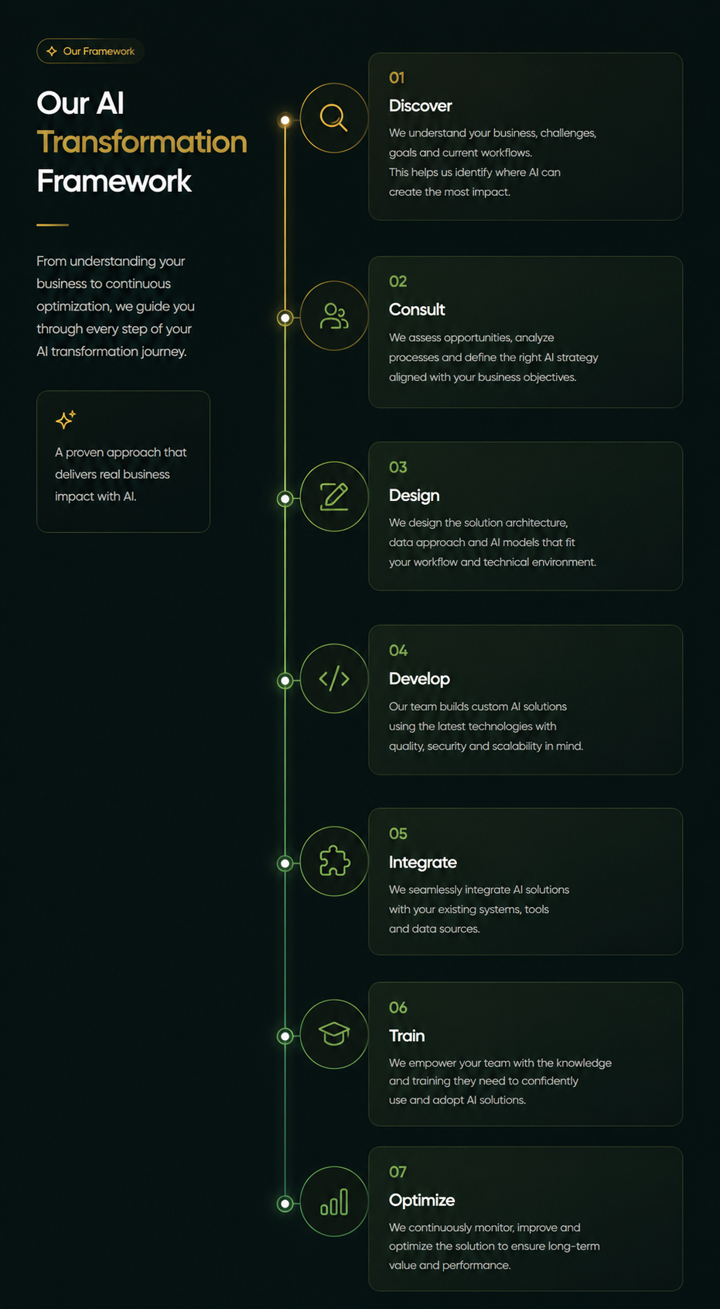

7- Trusted By section (You already done)
8- Why work with us (Design left)

9- FAQ section
Make FAQ section like this: (use any icon on the left side instead of color full graphics like this). When user clicks on down arrow , it should show the answer below like the first question in the image.
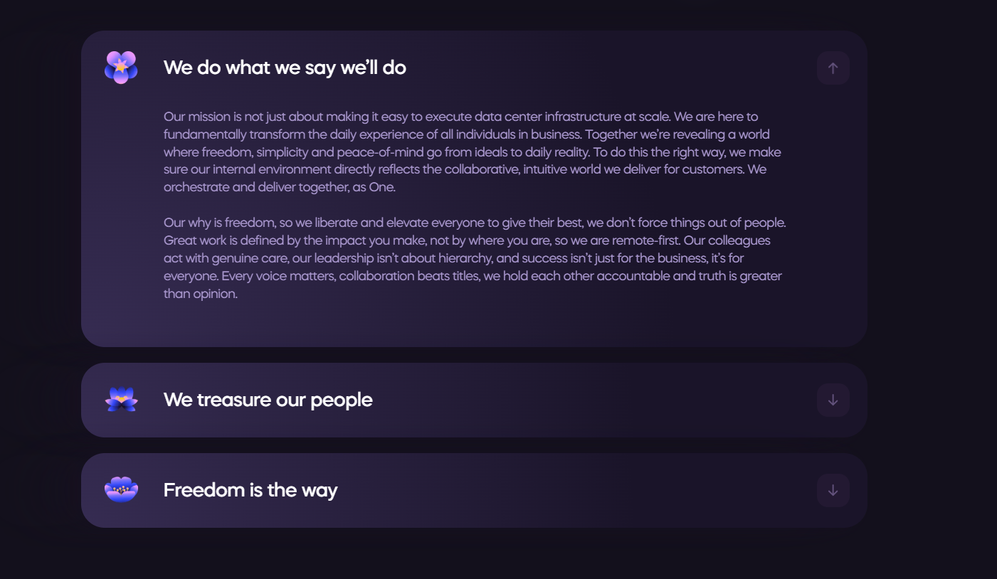
10- Testimonials
11- Final CTA
12- Footer

